**Personal Loan Eligibility check** will be based on customers previous banking relations and ranking/score.

General Process:-

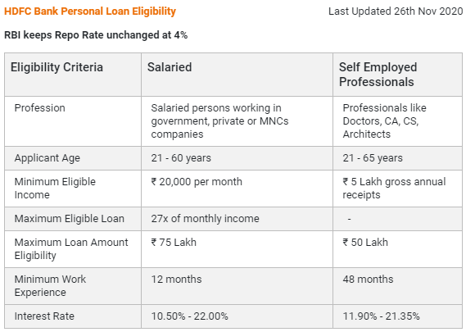

Bank Personal Loan Eligibility based on **CIBIL Score**

* + **CIBIL Score:** Your credit behaviour and track record from your past lenders and credit card providers get captured in your CIBIL score. CIBIL score is the most important factor to define your eligibility to get a personal loan. When checking eligibility for a personal loan, Bank will check the complete Credit report, which also includes all past running loans and your payment track record on loans and credit cards. Higher credit score increases your chances that your loan application from Bank will get approved. However, low CIBIL score decreases your eligibility to get a personal loan. Bank requires a minimum credit score of 650 to be eligible for a personal loan.

There are a few factors which affect your credit score -

* + **Late payments on past loans –**Any delay in payments on your existing or past loans can negatively affect your CIBIL score and it may also reduce your chances of getting a personal loan from Bank.
  + **High number of unsecured loans –**Always maintain a balance between secured and unsecured loans. Higher proportion of unsecured loans in your total borrowings can negatively impact your credit score.
  + **Usage of credit limit –**Your credit card bills and usage of credit limit determine your credit behaviour. Frequent withdrawals and spending more than your credit card limit can be seen as a sign of potential financial stress, credit indiscipline and hence, may pull down your credit score.
  + **Multiple loan applications –** If you apply for a personal loan in multiple banks at one time, it can affect your score negatively and reduce your CIBIL score. In case of application rejection from Bank, improve your credit worthiness to get a good score and your loan application to get approved.